Data analytics assignment   
Covid-19 Cases in ireland  
Seona Callanan  
Lecturer: Yash Iyengar

18th September 2021

Abstract

Ordnance Survey Ireland carried created a document including the Covid-19 statistics on a daily basis. The data is based on Health Service Executive’s initial data. Due to the Cyber Attack on the HSE’s IT infrastructure in May, there is a gap in the data where new Covid-19 data information. This data focuses on the Covid-19 confirmed cases, the county they were reported in and the population in the county.

Introduction

I decided to use this data set and in particular, chose the Covid-19 topic due to the prevalence of it during current times. This data set gives a great insight into how each individual county in Ireland has been impacted by Covid-19 and how badly. Although Covid-19 is a hot topic currently for many individuals for the last 18 months, it is interesting to look at the past 18 month’s and Covid-19’s impact as a whole. This data will provide historical insights in the impacts of a pandemic on a country in years to come.

Dataset

The dataset that I have chosen, contains factual information on the Covid-19 statistics in Ireland and is available as a csv file. The dataset includes columns such as County, Time Stamp, Population and the number of Confirmed Cases. The dataset includes 14,535 rows and 101,738 variables.

Implementation Process

I have created a Python project of my csv file and made it available on a Pandas data frame. My analysis consists of two files which outlines the following:

For visualisation purposes, I have sorted my data in alphabetical order.

My file also includes indexing using iloc, sorting, slicing, iterrows and pulling out duplicates in the file. As the size of my dataset is large, NumPy was used in my coding.

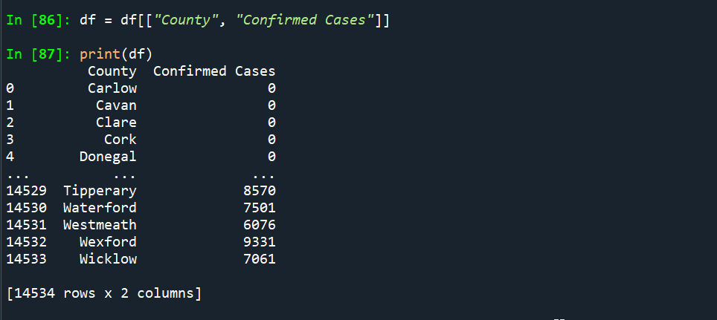

I created a custom function to print the total number of confirmed cases in the dataset. This is a great insight into how Ireland was affected by the Covid-19 virus.

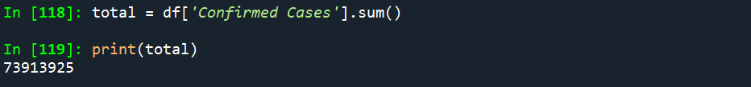

I used the Python Dictionary function on my a selection of columns.

Results

The first graph that I have created outlines the ‘Confirmed Cases per County’ using Matplotlib visualization. From this graph, it is clear that the majority of Covid-19 cases are confirmed in Dublin. It is also clear that the least number of cases have been confirmed in Carlow.

In this second visualistation graph using Matplotlib, it shows the number of ‘Confirmed Cases by Population’. This graph shows clearly that the areas, like Dublin and Cork how had the highest number of Covid-19 confirmed cases.

This final graph shows the number of ‘Confirmed Cases per Time Stamp’. This graph visualises that at the beginning, March 2020 cases were much lower than May 2021.

Insights

* Areas/county’s with a larger population have been significantly more affected than the counties with a smaller population.
* Covid-19 cases were much lower at the beginning of the pandemic and grew significantly from then.
* Some areas, such as Kildare have a higher number of Covid-19 confirmed cases, although the population isn’t large, unlike Dublin.
* It’s clear as the number of Covid-19 cases go in waves of high and low, which could be an impact of lockdowns in the country.
* Although there are large spikes in the counties with high confirmed cases, there is a high base number of Covid-19 cases across all counties.

References

Data.gov.ie. 2021. *Covid19CountyStatisticsHPSCIreland - data.gov.ie*. [online] Available at: <https://data.gov.ie/dataset/covid19countystatisticshpscireland1> [Accessed 18 September 2021].